PhD defense
Diabetes complications in Greenland: CVD and diabetic kidney disease in a unique genetic population

Maria Overvad, MD
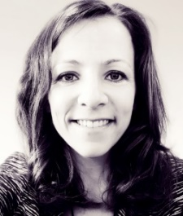

Friday, August 28, 2020
14.00-16.00
The defense and subsequent reception will take place at:
Steno Diabetes Center Copenhagen
Niels Steensens Vej 6, 2820 Gentofte
NSK building, Auditorium, ground floor
ZOOM link
Alternatively, you may join the defense using a link that will be sent in due time, when you register

What to bring
Bring a tablet/computer if you want to read a PDF copy of the thesis during the defense. There will not be printed copies. You will receive a PDF copy when you RSVP.

Corona/Covid19
We will abide by relevant health guidelines. Therefore, we ask that you register by

RSVP if you are coming to: maria.overvad@regionh.dk

Academic Supervisors
Marit Eika Jørgensen, Professor, MD, PhD
Clinical Epidemiology, Steno Diabetes Center Copenhagen; Health in Greenland, National Institute of Public Health, University of Southern Denmark and University of Greenland
Michael Lynge Pedersen, Dr. Med., MD, PhD
Greenland Center for Health Research, Institute of Nursing and Health Science, University of Greenland
Peter Bjerregaard, Professor, MD, PhD
Health in Greenland, National Institute of Public Health, University of Southern Denmark

Assessment committee
Ann-Dorthe Zwisler, Professor, MD (Chair)
National Centre of Rehabilitation and Palliation, University Hospital Odense, University of Southern Denmark, Odense, Denmark
Brent Richards, Associate Professor, MD
Departments of Medicine, Human Genetics, Epidemiology and Biostatistics, McGill University, Canada
Anders Koch, Professor, MD
Department of Infectious Disease Epidemiology and Prevention, Statens Serum Institut, Denmark

